**Accessing Canvas**

**Course Pages/Navigation**

**Basic Course Settings**

**Importing Previous Data**

**Broken Links**

**Updating Navigation**

**Modules & Pages**

**Assignments**

**Linking to Gradescope (Optional)**

**Quizzes**

**Class Roster**

**Course Sections (Cross-Listed)**

**Course Sections (Creating Your Own)**

**CRTP Information**

**Accessing Canvas**

To log into Canvas visit: <https://go.canvas.duke.edu/>. Near the top right corner, you will see: 

From there, use your Duke NETID to log into Canvas.

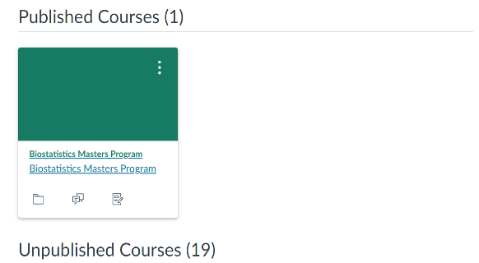Once you are logged in, you will generally land on the Dashboard page. Here you will find colorful squares that represent classes :

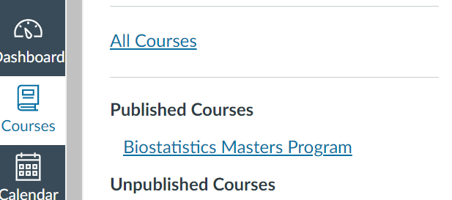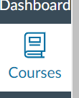

If you do not see the class that you are looking for, find “Courses” on the left hand side. Choose “All Courses” and you will find a list of courses that you are enrolled in. (Enrolled as a teacher, designer, student, etc.)

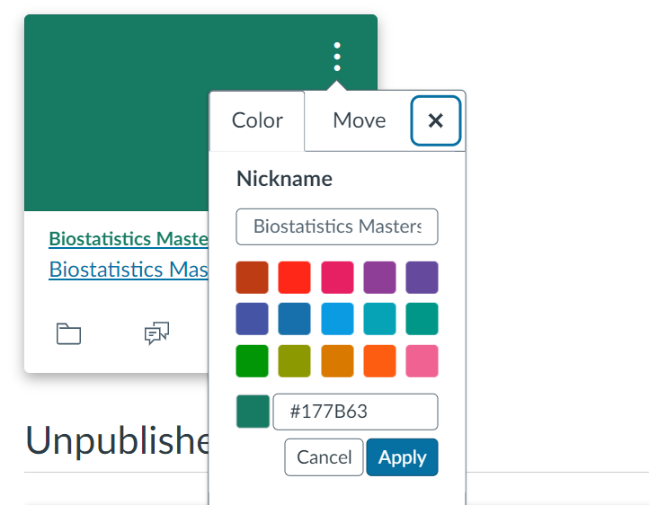If you manage multiple courses, you may wish to give the courses a nickname to make them easier to find. You can accomplish this by click on the three dots in the top right corner and then typing a new name into the nickname space. You can also change the color the course appears as.

Please note that these changes are for only your view. If you wish to change the appearance for everyone enrolled, you must do so in the course settings.

**Course Pages/Course Navigation**

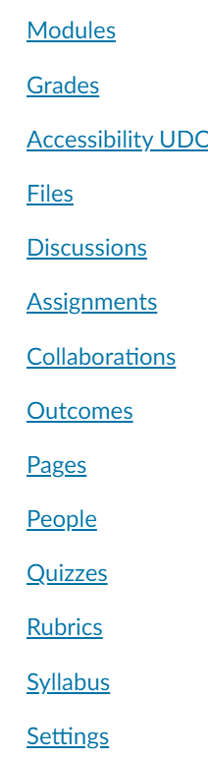Once logged into the course, you will have a navigation column to the right of the canvas navigation column. You can toggle this column by clicking the three lines in the top left-hand corner

You may not see all of these options shown to the left. And not all of them may be visible to students. Something that will not be visible is noted by an eye with a line through it. (To add items to the navigation column, please see the section about navigation)

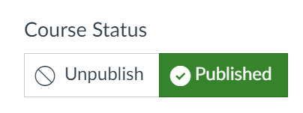

When you first log into the course, the course should appear as unpublished. When you are ready for students to be able to see the course, you will need to publish by clicking the publish button. At any time, you can unpublish the course so students cannot access the materials.

**On the people tab, please click +People and add** [**matthew.franco@duke.edu**](mailto:matthew.franco@duke.edu) **& thoma093@mc.duke.edu.**

**Basic Course Settings**

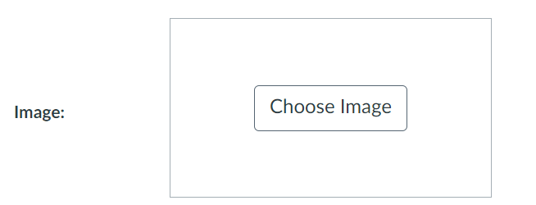In the settings tab, you have the option of changing the image for the course that will appear on the dashboard of all those who are enrolled.

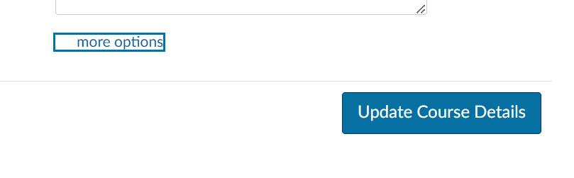

At the bottom of the course details page, you will find a link for more options:

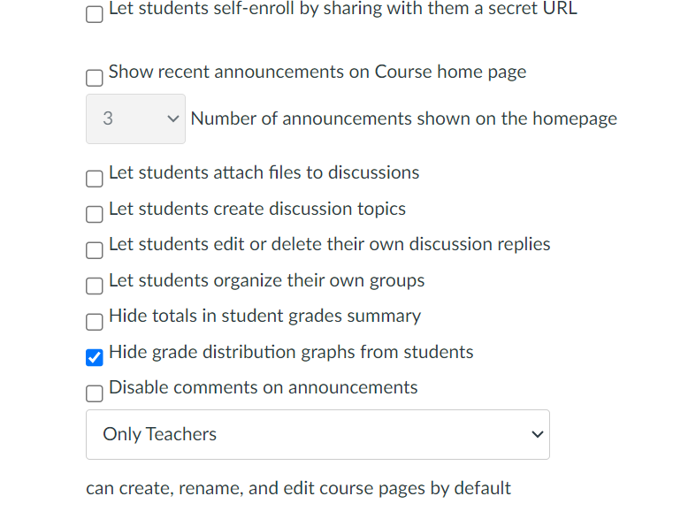

By clicking more options, you will see the options to the right. For small classes, I recommend hiding the grade distribution graphs from students. Remember to click Update Course Details to save all changes.

**Importing Previous Data**

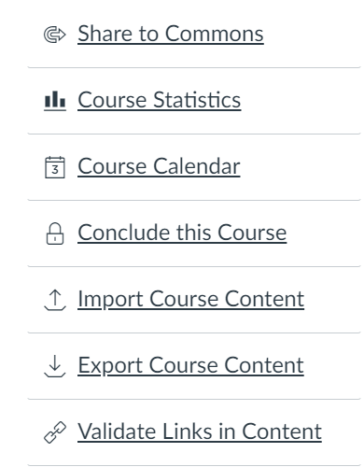Under the course details tab on the settings page, you will be able to import course content from previous courses. If you would prefer this process to be completed by Matthew Franco, please email him. [Matthew.Franco@duke.edu](mailto:Matthew.Franco@duke.edu)

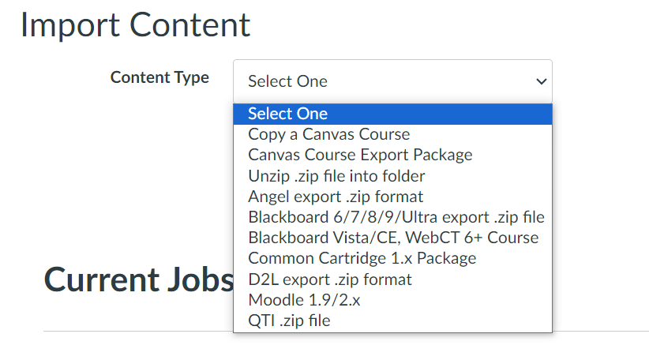After clicking import course content, you will be able to select how to import the content. Generally, you will choose a canvas course and then select the previous edition of the course you teach.

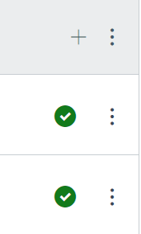

Find the course that you wish to import from**. PLEASE REMEMBER TO GO UNPUBLISH ALL ITEMS THAT YOU DO NOT WISH TO BE SEEN IMMEDIATELY. WITH A CLASS IMPORT, ALL ITEMS ARE NOW PUBLISHED.** To publish or unpublish an item, click the green check mark to unpublish or the circle with a line through it to publish. **An item is published if it has the green checkmark.**

**Broken Links**

As you proceed with editing your page, please remember to check the dates. The assignment will still be there, but you may have a different date in mind for this semester.

If links do not work, you will see a warning sign: 

I think this link is trying to redirect out of Sakai or open a new Sakai page, which cannot be done because we are no longer starting from Sakai. If you still have the link to the original item, you can use that url to fix the broken link.

**Updating Navigation**

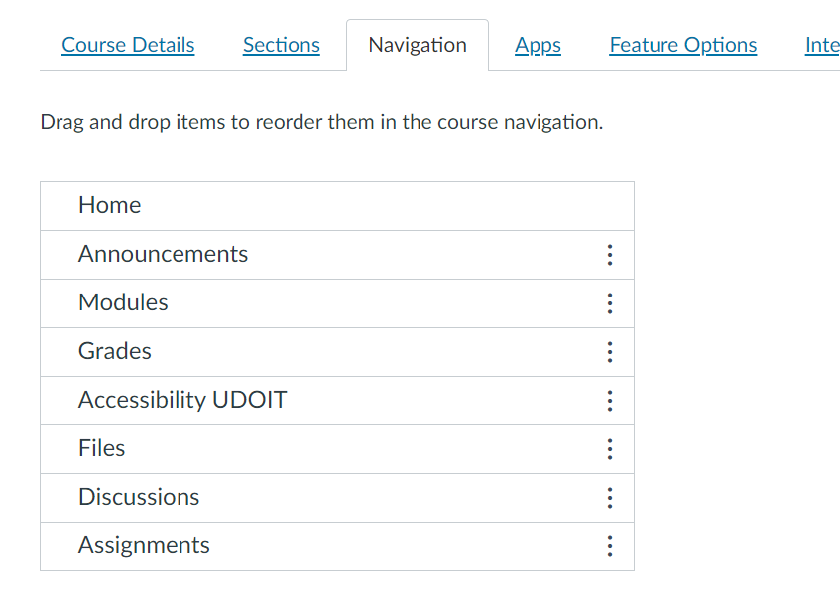

For the navigation tab, you can choose which pages you wish to be visible to students. You can click and drag items from the bottom to the top. For the page to be seen, you **MUST** click **“Save”** at the very bottom of the page

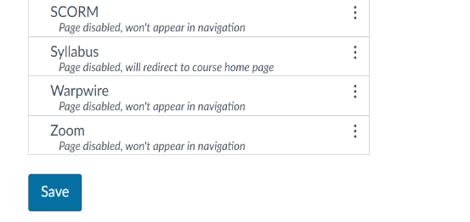



A page may not be visible to students for a few reasons. They may need to be added to the navigation list, or there may be no content.

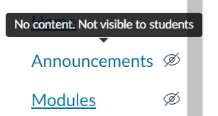If you hover over the page and it states no content, then the page will not be seen by students until there is something to be seen. If there is content and the eye remains, you may need to go into the page and manually publish it.

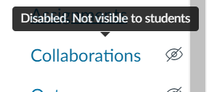

If the page says disabled, then you must enable the page on the navigation page in settings. If you enabled it before and it is not showing, try again and click save at the bottom.

**Modules & Pages**

Most of your course content will go on to the Modules and Pages pages. Think of a module as a chapter in a book. To add a module, click the +Module button. You have the option of locking the module until a specific date. The Pages page is an area where one can add pages to the chapter and then link the information to the module.

You can add files by dragging and dropping or by clicking upload files. Please note that files that are uploaded will be available on the Files tab and appear as published as soon as they are uploaded.

After the initial file is added, the easiest way to add a file is to click the + next to the module to which you want to add the items and then [Create File(s)]. This will allow you to upload from your files. Of course, if the file has already been added to the files folder, you can find and add it that way.

**Assignments**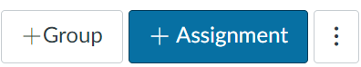

You will find the assignments page as part of the left-hand course navigation pane. At the top-right of the page, you can publish and unpublish the site, depending on whether you believe all is set for students to see the page. You can add assignments by clicking +Assignment. If you want different groups of assignments (classwork, homework, projects, presentations), you can create them by clicking +Group.

It is probably best to set up all of the assignment types first. Add Groups to accommodate the different assignment types, and then you can create your grading scale. (Assignment Groups Weight)

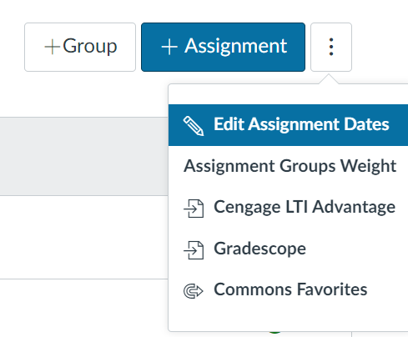

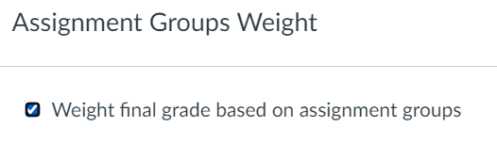

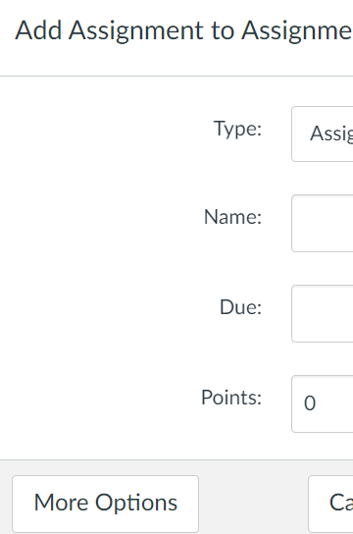To create an assignment, click on +Assignment. You will probably want to look at the “more options” tab.

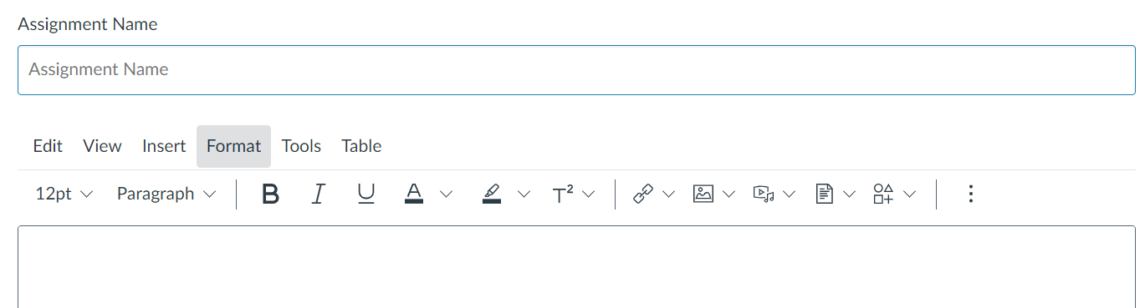When you create an assignment and view more options, you will see a page like this: at the very beginning, you should just include the assignment name and any additional information you would like to include.

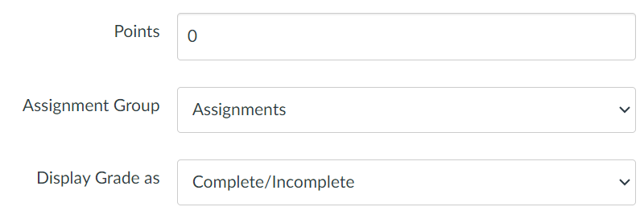Enter the maximum number of points possible for the assignment, which group the assignment belongs to, and how the grade will be displayed.

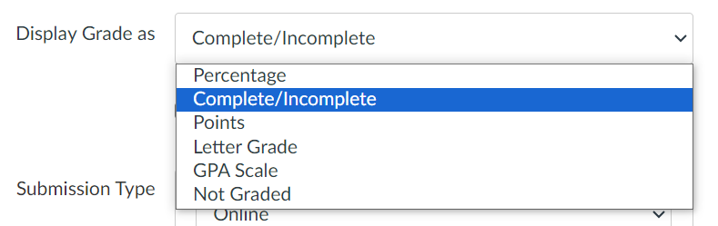Select how you want the grade to appear in the gradebook. (Please note that if the assignment has 0 possible points and you use Complete/Incomplete, even when marked complete, the grade will download to Excel as a 0 because that is the grade for a complete assignment)

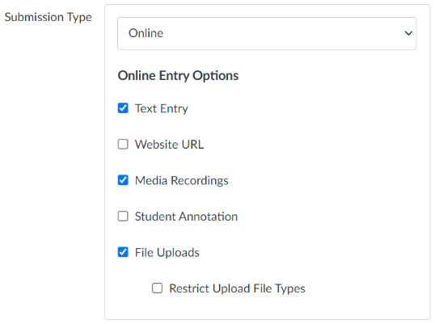

You can choose how

Pdf, docx, xls are examples of file type restrictions

you want students to submit

the assignment. For file

uploads, you can restrict the

type of files by adding the

file extension types,

separated by a comma.

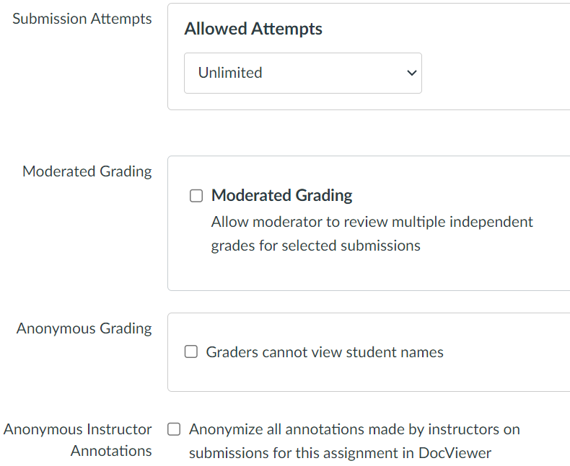Choose the number of submissions. The default seems to be unlimited.

Moderated Grading to allow multiple people to grade the assignment and give feedback. Ultimately, the instructor will need to award the final grade for the assignment.

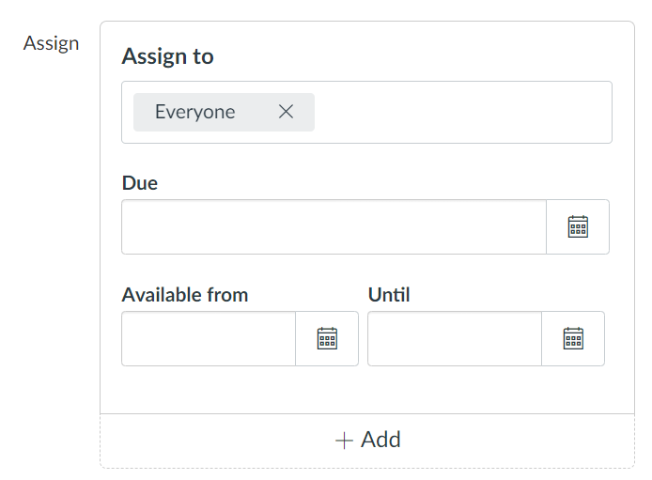

Choose who you wish to assign to, when the assignment is due, and how long the submit window and details are available. You can choose different dates and times for different sections if you choose. (To create sections, please read the title about Course Sections.)

**Linking to Gradescope (OPTIONAL)**

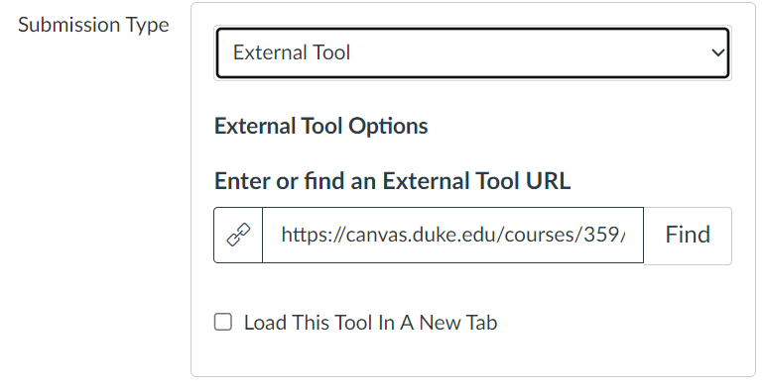You can link the assignment to Gradescope by choosing external tool, clicking find, and selecting the Gradescope tool.

Below, you will see the link resource popup for Gradescope. Click Find and choose the tool you wish to use. Note: You **DO NOT NEED** to do this. Assignments can live on Gradescope without being linked to the assignments page. You will however need to make sure all assignments are on Canvas or Gradescope if you want one of those programs to be the official gradebook.

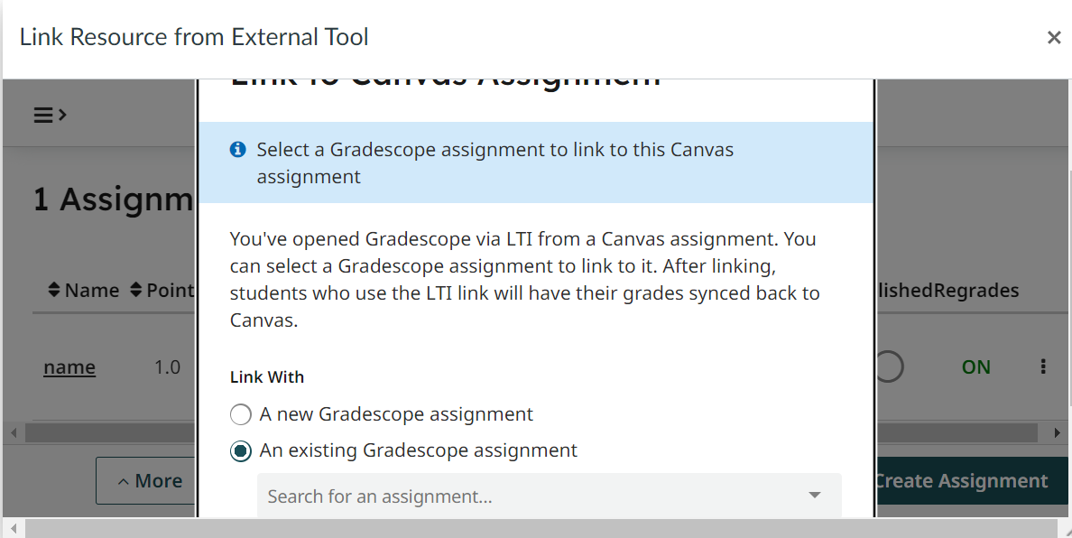

You can also follow this same process to have quizzes be part of the assignment page. Before using external tool to choose the quiz tool, go into quizzes, export the quiz that is already created, and then import that content to create the new quiz. This process is not necessary, as you can just edit the quiz and choose which assignment group the quiz should be a part of.

**Quizzes**

Quizzes can be added like assignments, but they are graded automatically (if able) by Canvas. To create a quiz hit the +Quiz button, name the quiz, set when it is due and then click Build.

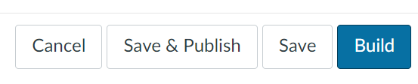

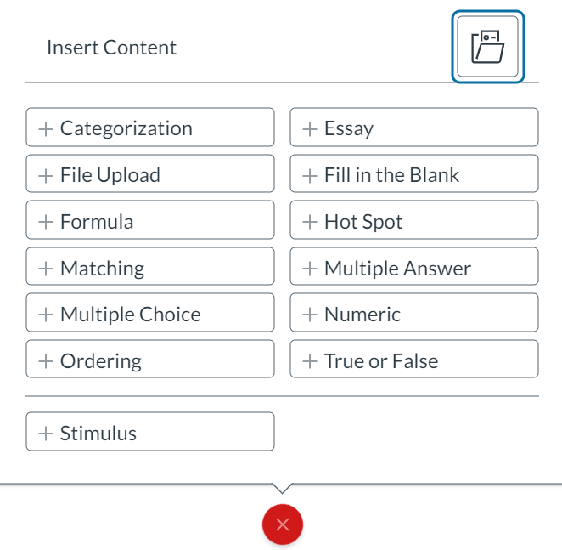

When building the quiz, press the + button to add questions. To the right, you will see question types. For questions that Canvas can automatically grade, make sure that you have selected the correct answer choice.

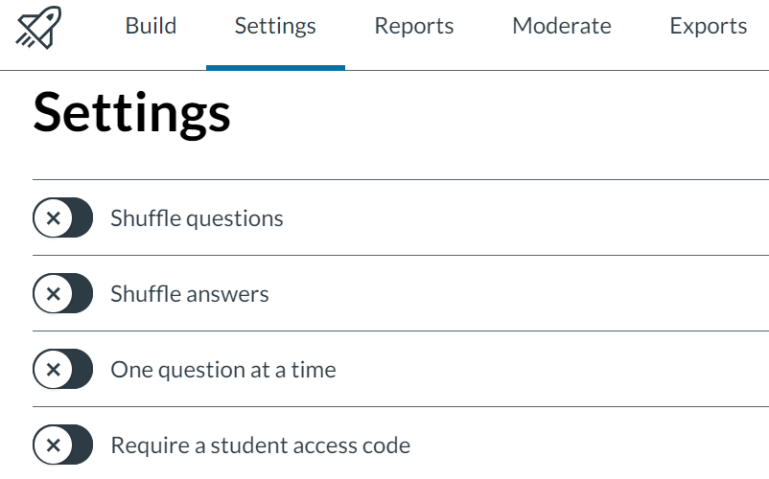

On the settings tab, there are many options. I would suggest at least shuffling the answers. If you want students to be in class to take the quiz, you can require a student access code. You will be able to choose your own password.

**Class Rosters (Printable)**

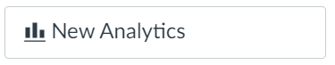The class list may be found on the home page>New Analytics>Reports> Run Report (next to Class Roster)

(On the right of the home page)   (Right of center top)

**Course Sections (Cross-Listed)**

Courses that are cross-listed will have multiple Canvas pages. Updating multiple pages is probably not something that you will want to do. If your class is cross-listed, e-mail [matthew.franco@duke.edu](mailto:matthew.franco@duke.edu) with the course you want to be the main course (Biostat, CompSci, Stat, etc.)

If you would like to combine them yourself, please follow these steps:

* Go to the course page that you want to be the main page. In the URL, copy the numbers that come after /courses/
* Go to the course page you want to add to the main page. **DO NOT** cross-list on the page where you want to be the main page. Cross-list on the other pages. Proceed to Settings > Sections.
* Click the blue link of the title for your course
* 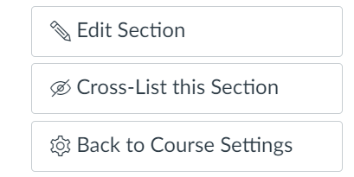Cross-List this Section
* Paste the class code of the main course

**Course Sections (Creating your own)**

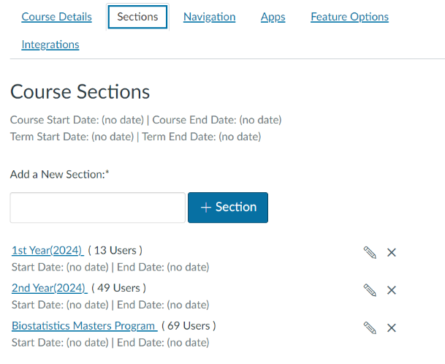Course sections can also be used to create lists of students that are easy to add to an assignment, announcement, or discussion. Name the group and click +section.

Before you add anyone to the different sections, please go to Settings and click on “more options” at the bottom of the Course Details tab.



Select the Hide sections on the People page option from students and click Update Course Details. I would also recommend you **DO NOT** title a section “extended time 1.5.” Perhaps Vanguard 1.5. or Jurassic Park 2. (Please note that you do not need to do this for quizzes, as the setting for extended time can be found under the moderate tab in the quiz itself.)

You may need also to create a different section of individuals who do not have extended time. Once again, **DO NOT** title that “Normal Time” or “Regular” Perhaps Easy Company 1.0 or Tron Original.

**CRTP Information**

**For CRTP classes only!!!** Please include the following links as an announcement or the very first module:

* <https://biostat.duke.edu/education-and-training/clinical-research-training-program>
* <https://hr.duke.edu/benefits/educational/employee-tuition-assistance/>
* [CRTP Program Information](https://duke.box.com/s/itxskn9s7z845fc5tyw0bynozyqdzg9h)
* [CRTP Research Project Information](https://duke.box.com/s/7589vh8jv0swqiwuj1aohe3fm0es0uoc)
* <https://registrar.duke.edu/bulletins/>
* <https://duke.hosted.panopto.com/Panopto/Pages/Viewer.aspx?id=b43cfb2b-2600-4581-900c-b06c01271039>
* <https://duke.hosted.panopto.com/Panopto/Pages/Viewer.aspx?id=cc2fc608-5816-4dcb-a2b1-b1cd00e97bd2>